Name: ____________________________ | Date: ________________

Practice the days of the week
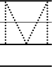
www.eslwritingwizard.com

